***Following Steps to be done for Executing the SOA Program***

1. First it will take the business partner whose U_SOA = ‘YES’ and loop it to send the email.
2. Get the Previous month last date based on current date and check the aging for the SOA date and the customer
3. If the aging meets the requirement, then we will go for sending the email.
4. Once the email is send out, we will maintain the email send log in following table

“[@EMAILLOG_SOA]”



1. Every time if the program runs, we are checking the email log table. If the email already sent, we are not sending one more time.
2. The Email template is stored in the program Folder “Email Template”. IF you want to change the email content, you can go and change it in the Email Template 1

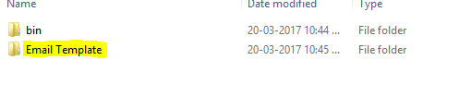

1. While sending the email, we were creating the report as PDF and send the PDF as attachment along with the email.
2. The generated PDF we are storing on the Program PDF folder as below

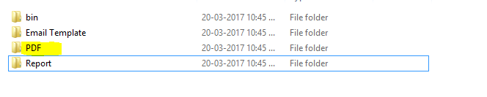

1. The Crystal Report is stored in the Reports Folder as below

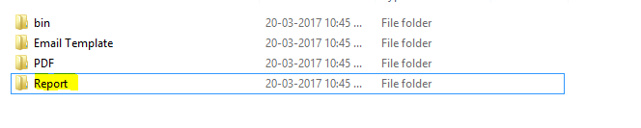

1. If the email program got any error while sending , we are grouping the email contents and send to Email id which we configured in the configuration file as below and Error email subject also configured as below

File Name: SOA_StatementofAccount.exe.config in the bin folder



1. You can run the exe program which is in the bin / debug folder in the name of “SOA_StatementofAccount.exe”
2. Before running the exe, you can change all the configuration details as you needed which is under the bin/debug folder.